Logistics Optimization for Delivery Routes – Amazon
Task 1: Data Cleaning & Preparation
● Identify and delete duplicate Order_ID records.
SELECT Order_ID, COUNT(*) as duplicate_count
FROM Orders
GROUP BY Order_ID
HAVING COUNT(*) > 1;
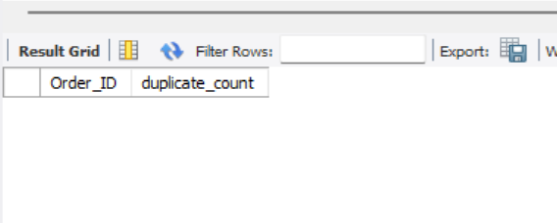
● Replace null Traffic_Delay_Min with the average delay for that route.
UPDATE Routes r1
LEFT JOIN (
SELECT AVG(Traffic_Delay_Min) as avg_delay
FROM Routes
WHERE Traffic_Delay_Min IS NOT NULL
) r2 ON 1=1
SET r1.Traffic_Delay_Min = COALESCE(r1.Traffic_Delay_Min, r2.avg_delay);
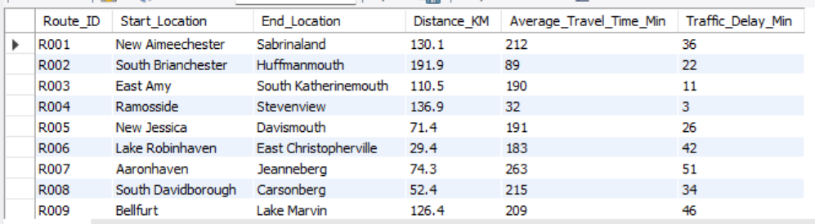
● Convert all date columns into YYYY-MM-DD format using SQL functions.
UPDATE Orders
SET
Order_Date = STR_TO_DATE(Order_Date, '%Y-%m-%d'),
Expected_Delivery_Date = STR_TO_DATE(Expected_Delivery_Date, '%Y-%m-%d'),
Actual_Delivery_Date = STR_TO_DATE(Actual_Delivery_Date, '%Y-%m-%d');
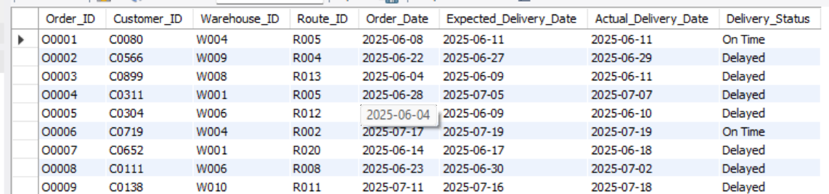
● Ensure that no Actual_Delivery_Date is before Order_Date (flag such records).
ALTER TABLE Orders
ADD COLUMN Date_Anomaly VARCHAR(10) DEFAULT NULL;

UPDATE Orders
SET Date_Anomaly = 'INVALID'
WHERE Actual_Delivery_Date < Order_Date;

Task 2: Delivery Delay Analysis
● Calculate delivery delay (in days) for each order .
ALTER TABLE Orders
ADD COLUMN Delay_Days INT;

UPDATE Orders
SET Delay_Days = DATEDIFF(Actual_Delivery_Date, Expected_Delivery_Date);
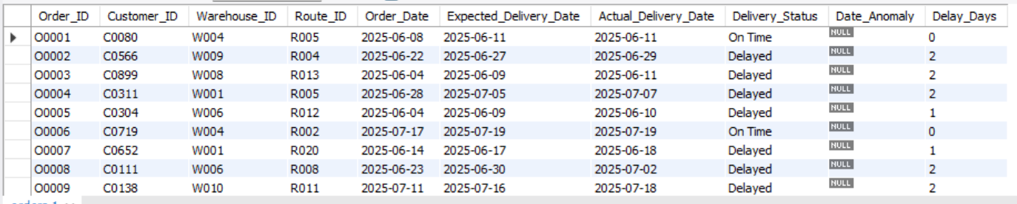
● Find Top 10 delayed routes based on average delay days.
SELECT
r.Route_ID,
r.Start_Location,
r.End_Location,
AVG(o.Delay_Days) as Avg_Delay_Days
FROM Orders o
JOIN Routes r ON o.Route_ID = r.Route_ID
WHERE o.Delay_Days > 0
GROUP BY r.Route_ID, r.Start_Location, r.End_Location
ORDER BY Avg_Delay_Days DESC
LIMIT 10;
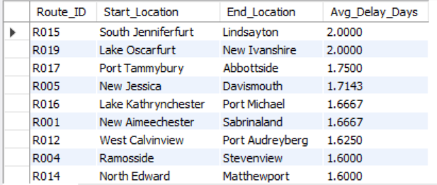
● Use window functions to rank all orders by delay within each warehouse.
SELECT
Order_ID,
Warehouse_ID,
Delay_Days,
RANK() OVER (PARTITION BY Warehouse_ID ORDER BY Delay_Days DESC) as Delay_Rank
FROM Orders
WHERE Delay_Days > 0;
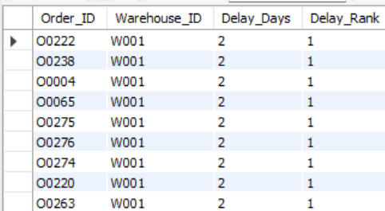

Task 3: Route Optimization Insights
● For each route, calculate:
○ Average delivery time (in days). ○ Average traffic delay. ○ Distance-to-time efficiency ratio: Distance_KM / Average_Travel_Time_Min.
SELECT r.Route_ID, r.Start_Location, r.End_Location, r.Distance_KM, AVG(DATEDIFF(o.Actual_Delivery_Date, o.Order_Date)) as Avg_Delivery_Time_Days, AVG(r.Traffic_Delay_Min) as Avg_Traffic_Delay_Min, (r.Distance_KM / NULLIF(r.Average_Travel_Time_Min, 0)) as Distance_Time_Ratio FROM Routes r JOIN Orders o ON r.Route_ID = o.Route_ID GROUP BY r.Route_ID, r.Start_Location, r.End_Location, r.Distance_KM, r.Average_Travel_Time_Min;
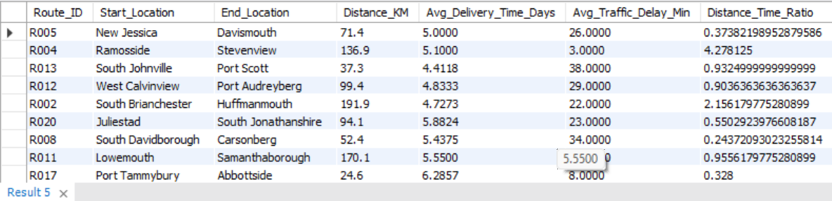
● Identify 3 routes with the worst efficiency ratio.
SELECT
Route_ID,
Start_Location,
End_Location,
(Distance_KM / Average_Travel_Time_Min) as Efficiency_Ratio
FROM Routes
ORDER BY Efficiency_Ratio ASC
LIMIT 3;
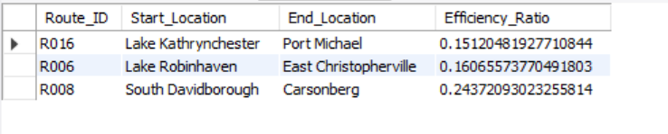
● Find routes with >20% delayed shipments.
SELECT
r.Route_ID,
r.Start_Location,
r.End_Location,
COUNT(*) as Total_Shipments,
SUM(CASE WHEN o.Delivery_Status = 'Delayed' THEN 1 ELSE 0 END) as Delayed_Shipments,
(SUM(CASE WHEN o.Delivery_Status = 'Delayed' THEN 1 ELSE 0 END) * 100.0 / COUNT(*)) as Delayed_Percentage
FROM Routes r
JOIN Orders o ON r.Route_ID = o.Route_ID
GROUP BY r.Route_ID, r.Start_Location, r.End_Location
HAVING Delayed_Percentage > 20;
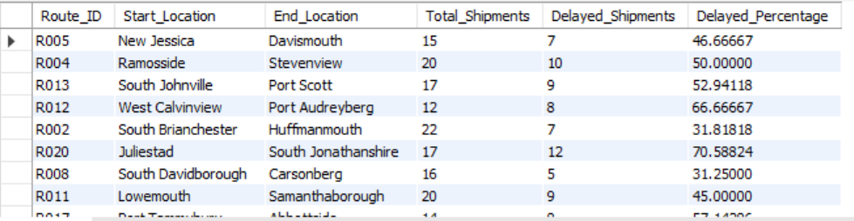
Task 4: Warehouse Performance
● Find the top 3 warehouses with the highest average processing time.
SELECT
Warehouse_ID,
Location,
Processing_Time_Min
FROM Warehouses
ORDER BY Processing_Time_Min DESC
LIMIT 3;
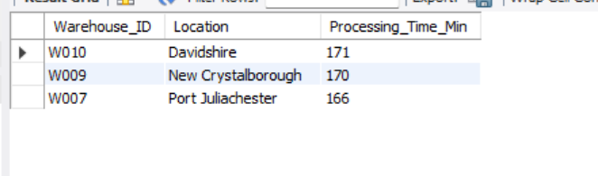
● Calculate total vs. delayed shipments for each warehouse.
SELECT
w.Warehouse_ID,
w.Location,
COUNT(o.Order_ID) as Total_Shipments,
SUM(CASE WHEN o.Delivery_Status = 'Delayed' THEN 1 ELSE 0 END) as Delayed_Shipments,
(SUM(CASE WHEN o.Delivery_Status = 'Delayed' THEN 1 ELSE 0 END) * 100.0 / COUNT(*)) as Delayed_Percentage
FROM Warehouses w
LEFT JOIN Orders o ON w.Warehouse_ID = o.Warehouse_ID
GROUP BY w.Warehouse_ID, w.Location;
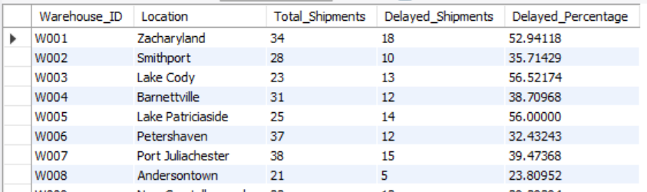

● Use CTEs to find bottleneck warehouses where processing time > global average.
WITH GlobalAverage AS (
SELECT AVG(Processing_Time_Min) as Global_Avg_Processing_Time
FROM Warehouses
)
SELECT
w.Warehouse_ID,
w.Location,
w.Processing_Time_Min,
g.Global_Avg_Processing_Time
FROM Warehouses w
CROSS JOIN GlobalAverage g
WHERE w.Processing_Time_Min > g.Global_Avg_Processing_Time;
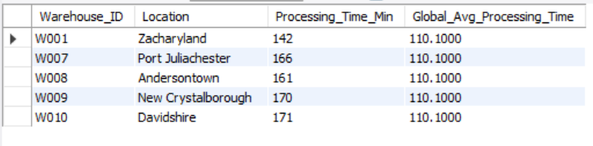

● Rank warehouses based on on-time delivery percentage.
SELECT
w.Warehouse_ID,
w.Location,
COUNT(o.Order_ID) as Total_Orders,
SUM(CASE WHEN o.Delivery_Status = 'On Time' THEN 1 ELSE 0 END) as On_Time_Orders,
(SUM(CASE WHEN o.Delivery_Status = 'On Time' THEN 1 ELSE 0 END) * 100.0 / COUNT(*)) as On_Time_Percentage,
RANK() OVER (ORDER BY (SUM(CASE WHEN o.Delivery_Status = 'On Time' THEN 1 ELSE 0 END) * 100.0 / COUNT(*)) DESC) as Warehouse_Rank
FROM Warehouses w
LEFT JOIN Orders o ON w.Warehouse_ID = o.Warehouse_ID
GROUP BY w.Warehouse_ID, w.Location;
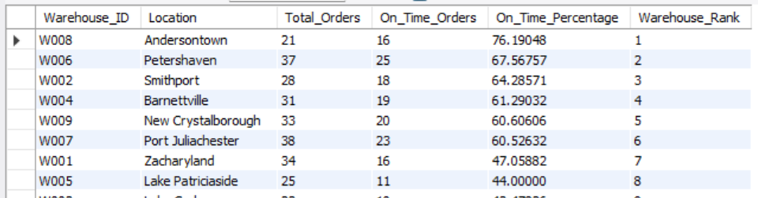
Task 5: Delivery Agent Performance
● Rank agents (per route) by on-time delivery percentage.
SELECT
Agent_ID,
Route_ID,
On_Time_Percentage,
RANK() OVER (PARTITION BY Route_ID ORDER BY On_Time_Percentage DESC) as Rank_Per_Route
FROM deliveryagents;
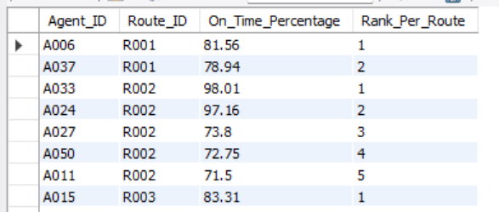
● Find agents with on-time % < 80%.
SELECT
Agent_ID,
Route_ID,
On_Time_Percentage
FROM deliveryagents
WHERE On_Time_Percentage < 80;
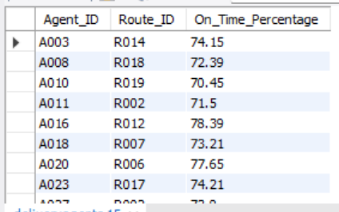
● Compare average speed of top 5 vs bottom 5 agents using subqueries.
WITH RankedAgents AS (
SELECT
Agent_ID,
On_Time_Percentage,
Avg_Speed_KM_HR,
ROW_NUMBER() OVER (ORDER BY On_Time_Percentage DESC) as top_rank,
ROW_NUMBER() OVER (ORDER BY On_Time_Percentage ASC) as bottom_rank
FROM deliveryagents
)
SELECT
'Top 5 Agents' as Category,
AVG(Avg_Speed_KM_HR) as Average_Speed
FROM RankedAgents
WHERE top_rank <= 5

UNION ALL
SELECT
'Bottom 5 Agents',
AVG(Avg_Speed_KM_HR)
FROM RankedAgents
WHERE bottom_rank <= 5;
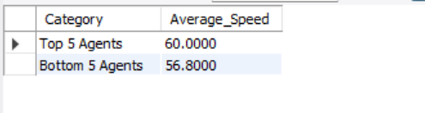
Task 6: Shipment Tracking Analytics
● For each order, list the last checkpoint and time.
SELECT
st1.Order_ID,
st1.Checkpoint as Last_Checkpoint,
st1.Checkpoint_Time as Last_Checkpoint_Time
FROM shipment_tracking st1
INNER JOIN (
SELECT
Order_ID,
MAX(Checkpoint_Time) as Max_Time
FROM shipment_tracking
GROUP BY Order_ID
) st2 ON st1.Order_ID = st2.Order_ID AND st1.Checkpoint_Time = st2.Max_Time;
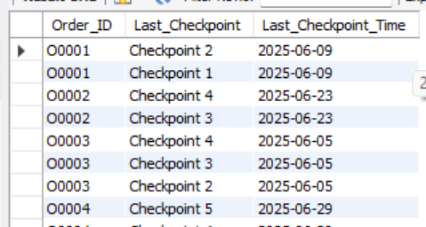
● Find the most common delay reasons (excluding None).
SELECT
Delay_Reason,
COUNT(*) as Frequency
FROM shipment_tracking
WHERE Delay_Reason != 'None'
GROUP BY Delay_Reason
ORDER BY Frequency DESC;
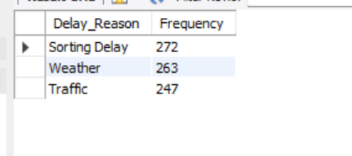
● Identify orders with >2 delayed checkpoints.
SELECT
Order_ID,
COUNT(*) as Delayed_Checkpoints_Count
FROM shipment_tracking
WHERE Delay_Reason != 'None'
GROUP BY Order_ID
HAVING COUNT(*) > 2;
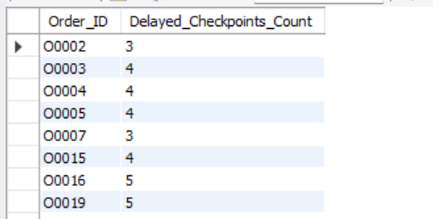

Task 7: Advanced KPI Reporting
a.Average Delivery Delay per Region (Start_Location).
SELECT
r.Start_Location as Region,
AVG(o.Delay_Days) as Avg_Delay_Days
FROM Orders o
JOIN Routes r ON o.Route_ID = r.Route_ID
WHERE o.Delay_Days > 0
GROUP BY r.Start_Location;
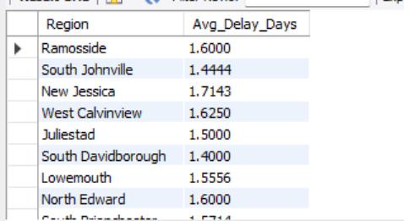
b. On-Time Delivery % = (Total On-Time Deliveries / Total Deliveries) * 100.
SELECT
(COUNT(CASE WHEN Delivery_Status = 'On Time' THEN 1 END) * 100.0 / COUNT(*)) as On_Time_Delivery_Percentage
FROM Orders;
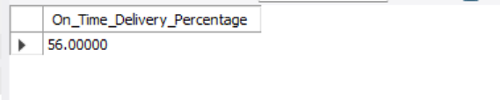

c.Average Traffic Delay per Route.
SELECT
Route_ID,
Start_Location,
End_Location,
AVG(Traffic_Delay_Min) as Avg_Traffic_Delay_Min
FROM Routes
GROUP BY Route_ID, Start_Location, End_Location;
